Secondary RE with ICT: A pupil’s entitlement to ICT in secondary RE

Becta in association with 
RE is a statutory subject in the curriculum. It has an important contribution to make in relation to young people’s ‘spiritual health’ and can make a major contribution to giving pupils insights into issues of sustainability, community cohesion and enterprise. No understanding of these issues will be complete without an appreciation of the role that is played by religious and faith communities.
ICT offers a range of powerful tools to help pupils to learn and to achieve high standards in RE. It can be used to find, develop, analyse and present information, as well as to model situations and solve problems. ICT enables rapid access to ideas and experiences from a wide range of people, communities and cultures, and allows pupils to collaborate and exchange information on a wide scale.
When planning to use ICT in RE lessons, teachers should consider whether the ICT is adding value to the lesson/activity. Would the RE learning outcomes be achieved as, or more effectively, without the use of ICT?
Effective use of ICT in RE should:
- be rooted in the RE learning objectives
- provide access to authentic information, insights and resources from the world’s religious communities – bringing the world of religion into the classroom
- allow pupils to investigate or be creative in ways not otherwise possible
- facilitate safe communication with peers and other communities, locally, nationally and globally
- give pupils access to information and resources not otherwise readily available
- engage pupils in the selection, critical use and interpretation of a wide range of information
- help pupils to think through and understand important, and complex, ideas
- support pupils in organising, recording, reporting and communicating findings
- support initiative and independent learning, enabling pupils to make informed judgements about when and where to use ICT to enhance their learning and the quality of their work
- enable pupils to see patterns or behaviours more clearly.
Note:
In maintained schools without a religious character RE should be taught according to their local agreed syllabus, which will be based on the non-statutory National Framework for RE (QCA, 2004).
Depending on the type of school and the wishes of parents, schools with a religious character may teach RE as determined by their governors in accordance with their trust deed. The agreed or aided school syllabus is the statutory document which sets out what pupils should be taught.
Academies must provide RE in accordance with the requirements for agreed syllabuses and have regard to the requirements of the non-statutory National Framework for RE (QCA, 2004) or, where the academy is designated as a school with a religious character, in accordance with the tenets of the specified religion or religious denomination (Academies Funding Agreement, DCSF, October 2006, pp.10–11).
This document provides some examples of how ICT can be used to support, enhance and develop learning and teaching in RE. These ideas are consistent with the non-statutory National Framework for RE, and are relevant to all syllabuses and specifications which are based on it.
Year 7
Reflecting on the Buddha
As part of a unit of work on Buddhism, a Year 7 teacher wanted her pupils to understand something of the importance and value of meditation for Buddhists. She used an online resource from CLEO showing Andy Weber, an artist specialising in Tibetan Buddhist art, drawing the Buddha’s face. Each student had access to a computer with internet access, and hard copy of a blank template which the teacher had downloaded from the site in advance.
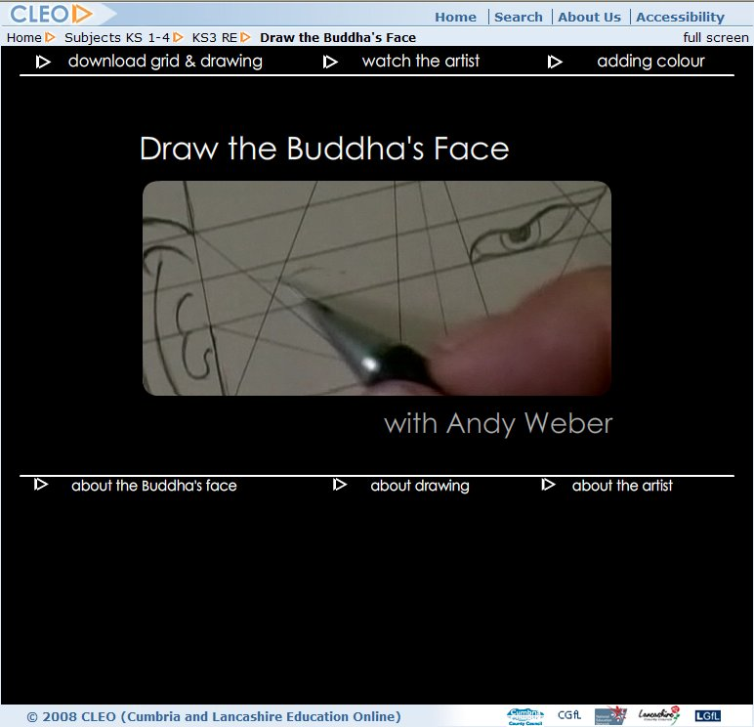
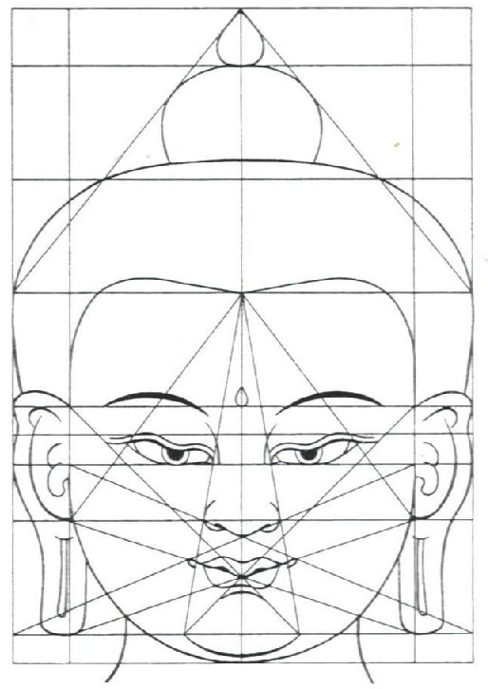
Pupils were asked to note down in a few words how they were feeling and to log on to the CLEO resource and follow the activity step by step to complete their own version of the Buddha’s face. The teacher asked them to follow the video sequences of the artist’s hand and work thoughtfully, and without speaking, concentrating on the movements of the artist’s hands, noting and copying the careful strokes of his pen, and read the text about Tibetan Buddhist art provided on screen.
When they had finished they were asked to:
- note down a few words which described how they felt
- compare their list with the one they wrote earlier, noting differences and speculating on reasons for any change
- share their list, and their image of the Buddha, with another pupil, talking about what they noticed – what was shared and what was different?
- express their feelings in an abstract piece of art of their own, or design something which represents the qualities of ‘serenity, detachment and enlightenment’ as they understood them. Pupils chose whether to use the computer or some other method for this task.
From this starting point, it was easier in subsequent lessons for pupils to understand what Buddhists mean when they talk about the process and importance of meditation, and also to have some starting points when discussing the importance of prayer for people of other religious traditions.
Framework theme
Expressing spirituality
Framework key processes
Interpret a range of sources, texts, authorities, and forms of religious and spiritual expression from a variety of contexts
Express their own beliefs and ideas, using a variety of forms of expression, including creative forms and reasoned arguments
Framework key concepts
Expressing meaning
Identity, diversity and belonging
QCA non-statutory unit of work (2007)
How do people express their spirituality through the creative arts? (Buddhism, Christianity, Hinduism and Islam)
Online resources
This activity is based on an online stimulus resource from CLEO
[www.cleo.net.uk/resources/displayframe.php?src=434/consultants_resources%2Freligiouseduc%2FbuddhaFaceNew%2Ftest01.html]
Other useful resources
- For a comprehensive collection of images of the Buddha from different traditions and cultures see the Buddha Image Archive [www.flyvision.org/sbm/bia]
- To find out about the work of Buddhist artist Andy Weber www.andyweberstudios.com
- For a comprehensive presentation of Buddhism for 11–14s see ‘Living Buddhism’, a DVD from Clear Vision Trust www.clear-vision.org
- For background information about contemporary Buddhism see BuddhaNet www.buddhanet.net
- There is a collection of short downloadable video clips about Buddhism from the BBC http://www.bbc.co.uk/learningzone/clips/
- A CD, ‘Stilling exercises for young people’ is available from Clear Vision Trust www.clear-vision.org
Understanding complex concepts
A Year 7 teacher wanted his class to understand the Hindu concept of Brahman, the One God often symbolised by the sound Aum.
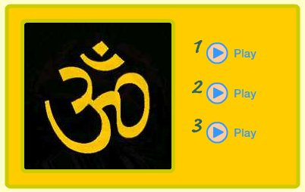
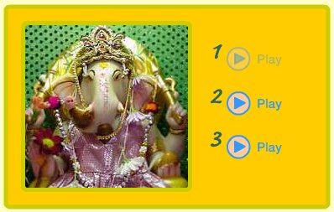
He used a short morphing sequence to check their understanding of this complex idea using a visual vocabulary that is part of the pupils’ culture. The concept of bodily transformation, as well as being an ancient and widespread theme in traditional narratives, frequently features in cartoons and science fiction. The morphing sequence used shows the Aum morph into Ganesh, Rama and Durga in turn.

He then asked the pupils:
- How effectively does the morphing sequence convey the concept of Brahman?
- How might the developers of the sequence make it look more dynamic?
- If the developers were to develop similar sequences for Christian and Muslim beliefs about God, what advice would they offer them?
- How would they express their own beliefs and questions about God in a morph sequence?
After the lesson some pupils used Flash software to create a morphing sequence of their own to express Christian, Muslim or their own beliefs and questions about God and presented them to the class.
Framework theme
Beliefs and concepts
Framework key processes
Explain religious beliefs, practices and commitments, including their transmission by people, texts and traditions
Express their own beliefs and ideas, using a variety of forms of expression, including creative forms and reasoned arguments
Framework key concepts
Beliefs, teachings and sources
Meaning, purpose and truth
QCA non-statutory unit of work (2007)
How do people express their spirituality through the creative arts? (Buddhism, Christianity, Hinduism and Islam)
Online resources
The morphing sequence on the Hindu concept of God is found in ‘Multimedia exploration of the Gujarat Hindu Temple in Preston’ from CLEO
http://www.cleo.net.uk/resources/displayframe.php?src=200/consultants_resources%2Fre%2Ftemplel%2Findex.htm] – choose ‘God, Gods and Goddesses’.
Other useful resources
- There is a free Time Morph tool on CLEO www.cleo.net.uk/resources/displayframe.php?src=150/consultants_resources%2Fre%2FtimeMorph02%2Ftimemorph.html]
- There is a collection of short downloadable video clips about the beliefs of Christianity, Hinduism, Islam, Judaism and Sikhism from the BBC http://www.bbc.co.uk/learningzone/clips/
- Strathclyde University http://www.strath.ac.uk/curricularstudies/re/db/reartefacts/hindudeities has a collection of downloadable images of Hindu deities
Investigating Religious Diversity
A Year 7 teacher wanted her pupils to investigate the nature and range of religious diversity within a locality as part of a unit of work on ‘Religion around us’.
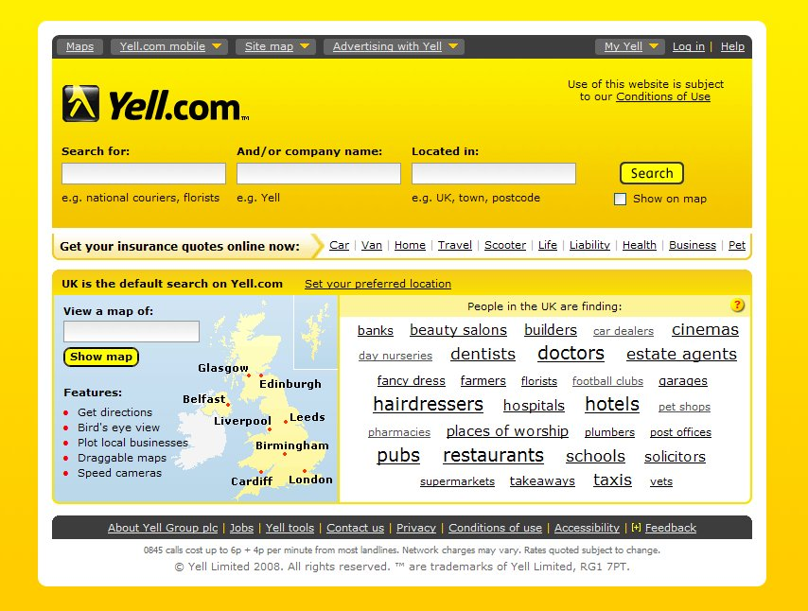
In preparation for a walk around the local area during an RE lesson in which pupils would be encouraged to look out for signs of religious activity (buildings, religious shops, symbols and people’s clothing, for example), they carried out an initial investigation using Yell.com to find out about the range of places of worship and religious organisations represented in the locality. After the walk, pupils would analyse their findings and draw some conclusions about religious diversity in the area.
In lesson one (of three) pupils used a dictionary to find and write down the meaning of ‘diverse’ and ‘diversity’. They fed back their findings to the class in response to the question: What examples of diversity can you see in our world?
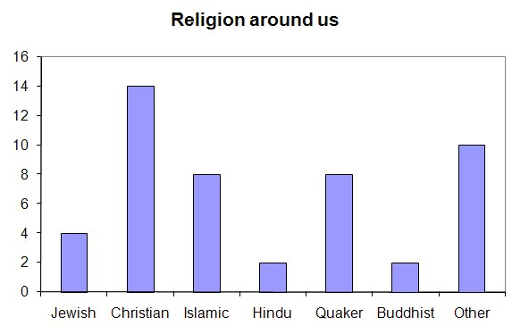
Next they considered the teacher’s outline of their task, and responded to a set of speculative questions, for example: What do they expect will be the outcomes of their findings? They completed their own research using Yell.com, recording frequency of each type of place of worship in a tally to categorise different types of places of worship by religion or denomination. The teacher demonstrated how to use Yell.com for the task, and also how to construct a tally chart.
They drew some quick general observations based on questions such as: Are all religions represented? Which are the most or least represented? What surprised them about their findings – why? They then devised a chart to represent their findings using pictograms, bar graphs or pie charts.
Use of Yell.com enabled pupils to access and interrogate a vast amount of data that would not have been easily available using a paper-based resource. Together with pupils’ own experiences and perceptions of the area, the data prompted new insights that enhanced their understanding of the locality.
Framework theme
Beliefs and concepts
Framework key processes
Interpret a range of sources, texts, authorities and forms of religious and spiritual expression from a variety of contexts
Evaluate beliefs, commitments and the impact of religion in the contemporary world
Framework key concepts
Practices and ways of life
Identity, diversity and belonging
Online resources
Yell.com http://www.yell.com
Other useful resources
- For inspiration and guidance on learning outside the classroom in RE see ‘Sacred Space’ on RE Online http://nou.refuel.org.uk/sacred-space/index
- There is information, guidance, videos and resources on places of worship in each of the six principal religions on RE Online http://pow.reonline.org.uk
Year 8
Analysing creation narratives
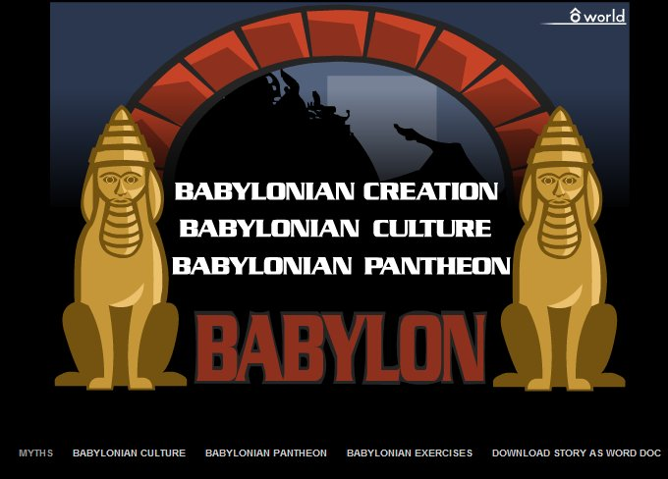
As part of a unit of work on creation narratives a teacher wanted his class of mixed-ability Year 8 pupils to analyse a range of creation narratives to identify and interpret the main themes expressed. The class was equipped with Tablet PCs (two pupils sharing), wireless data projector and ordinary whiteboard. The Big Myth website chosen as a resource for this lesson has a simple structure which helped pupils grasp what can be quite complex concepts, and to reflect these with understanding in their own work.
The teacher introduced the lesson by reminding pupils of the two creation narratives they had studied previously and the definition of the term ‘myth’. Prior to the lesson pupils had explored creation narratives including scientific theories using a range of resources including photographs, stories, poetry, drama, guided visualisation and textual analysis.
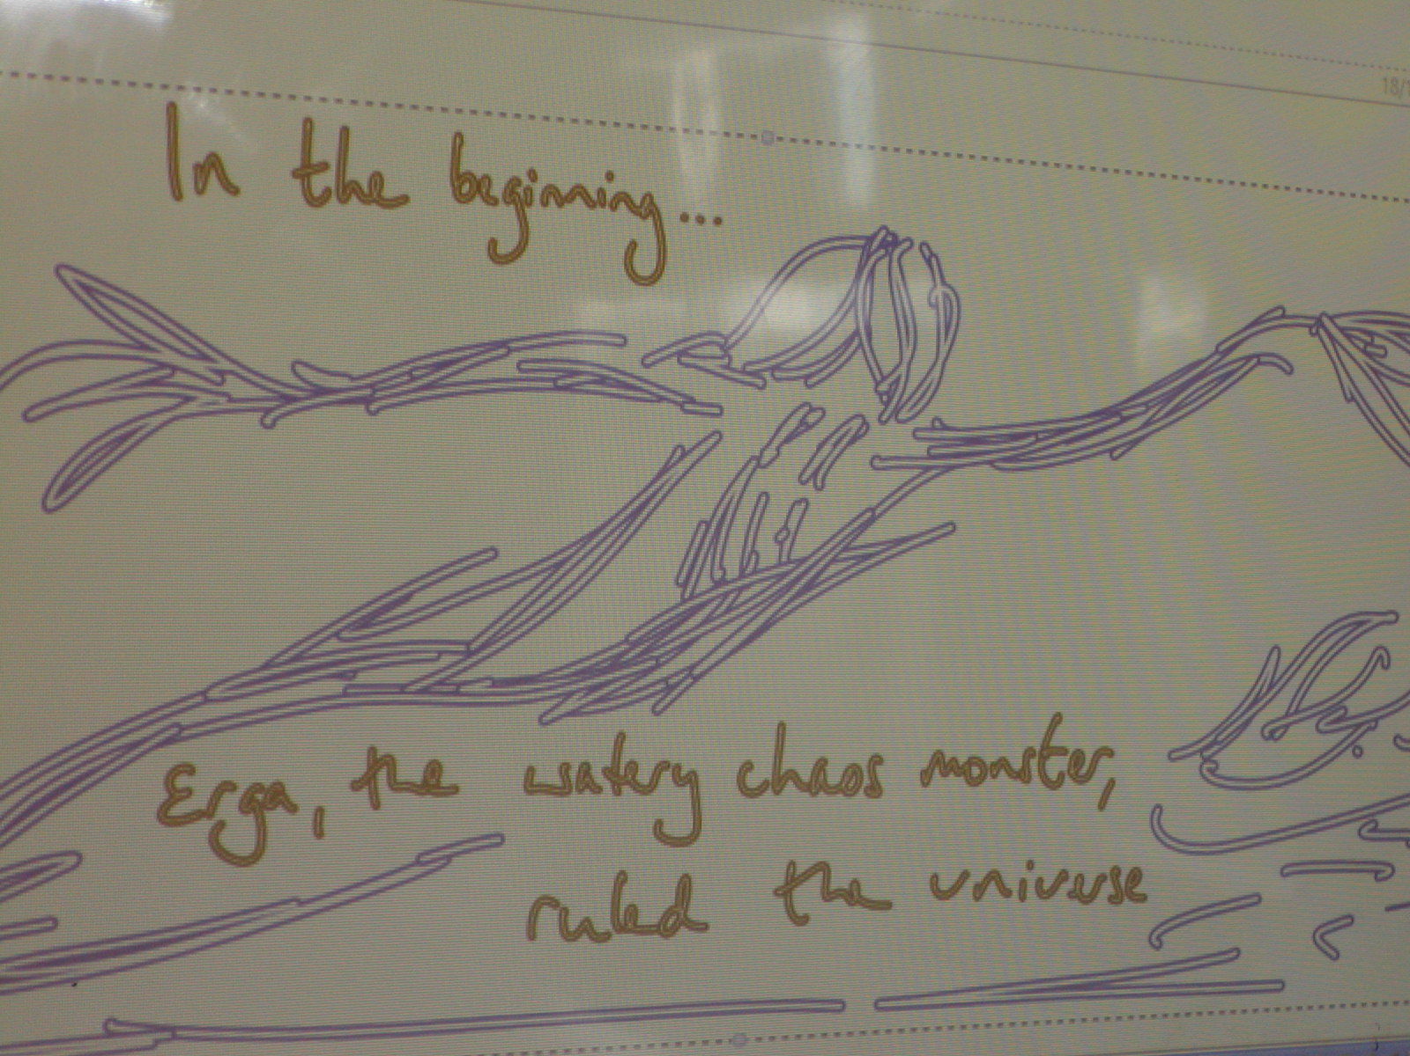
The teacher logged on to the Big Myth website and invited three pupils to select an animated creation narrative for the class to watch. Pupils noted down individually the key themes that the narratives had in common as a basis for teasing out what the ‘truth’ of each myth might be. Suggestions included: the gods wanted to be worshipped; there is a struggle; first time is not always the best; things start with the gods; bad brings good; gods learn by their mistakes; there is purpose.
Pupils then worked in pairs to share their suggestions for key themes. They watched one more creation narrative from the site and reviewed their list of key themes, adding and amending as appropriate.
Finally, they devised their own creation narrative to convey one of the truths they had identified. The Tablet PC provided flexibility and pace: all pupils could access the Big Myth websites themselves, they could work on the Tablet directly, and f the text recognition facility enabled them to create well-presented work.
Framework theme
Religion and science
Framework Key Processes
Analyse religious beliefs, arguments and ideas
Express their own beliefs and ideas, using a variety of forms of expression, including creative forms and reasoned arguments
Framework key concepts
Beliefs, teachings and sources
Meaning, purpose and truth
QCA non-statutory unit of work (2007):
How can we answer questions about creation and origins / Learning from religion and science (Christianity, Hinduism, Islam and Humanism)

Online resources:
The Big Myth website [www.bigmyth.com] is a collection of traditional creation accounts from around the world presented as Flash animation sequences. A supplementary CD-ROM can be purchased which extends the number of creation narratives to 25.
The impact of beliefs, values and commitments on decision-making
As part of a unit of work investigating how religious beliefs, values and commitments affect people’s decision-making, a Year 8 teacher with access to digital video cameras decided to build in a digital storytelling opportunity.
The teacher felt that this would bring the authentic voice of religion into the RE classroom and provide opportunities for dialogue with people of faith. It would also enable more creative ways of assessing pupils’ progress.
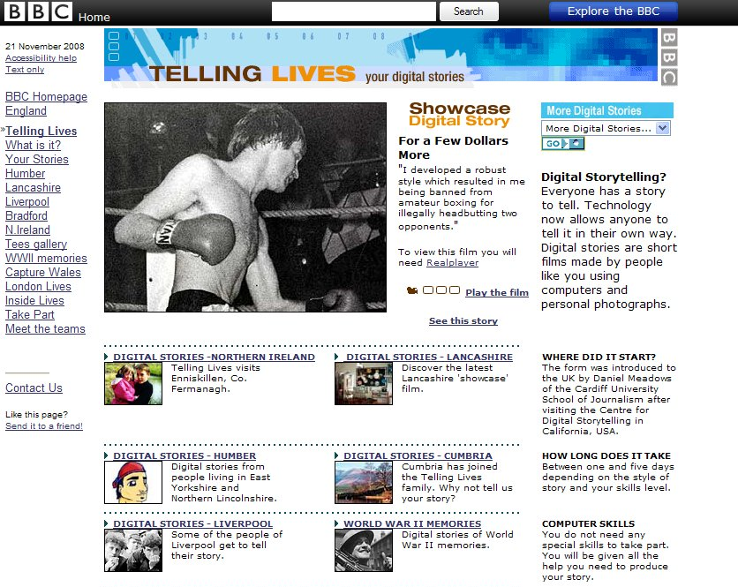
Following an introductory lesson in which ‘inspiration’ and ‘commitment’ were explored, pupils were introduced to the idea of digital stories. They reviewed a selection of digital stories from the BBC’s ‘Telling Lives’ website and developed an action plan for writing their own digital story based around the key idea of where people found inspiration and how their beliefs and values affected their decision-making. They then prepared a series of questions to ask people from a variety of faith communities reflected in the area around the school.
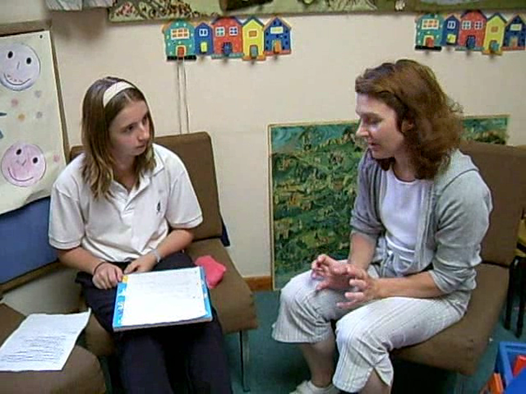
Once the planning stage was complete, pupils met the people who were willing to be interviewed. Some of the interviews took place on school premises, but many pupils visited the people in their place of worship or place of work. This was far more personal than inviting someone into the classroom for a question and answer session, and the conversations were able to go much deeper and were all the more eloquent in expressing the impact of beliefs and values on decision-making.
Pupils used digital cameras (video and stills) to capture their work and produced short digital stories to express what they had learned. The editing of the digital stories was completed in the ICT suite, with support from the ICT department. Once completed, pupils evaluated each other's work against an eight-level scale of achievement, shared with the class at the outset of the work.
Pupils’ evaluations showed they enjoyed the more ‘flexible’ way of working and had a sense of ownership of the task. They felt they had been more creative in their presentations, and effectively solved problems in the editing stage. They had learned about and reflected on the meaning of commitment for themselves and had worked more independently of the teacher, taking responsibility for their work.
Framework theme
Expressing spirituality
Framework key processes
Investigate the impact of religious beliefs and teachings on individuals, communities and societies, the reasons for commitment and the causes of diversity
Evaluate beliefs, commitments and the impact of religion in the contemporary world
Framework key concepts
Practices and ways of life
Identity, diversity and belonging
QCA non-statutory unit of work (2007)
How can beliefs and values serve as a guide for decision making? Transition Unit Part B: Communities (Christianity, Judaism and Sikhism)
Online resources
Telling Lives www.bbc.co.uk/tellinglives
For background information about digital story telling by Barrie Stephenson http://sightings.kidsown.ie/interviews/barrie_stephenson.php of BBC Telling Lives.
Year 9
Analysing how beliefs about God are portrayed in art
This Year 9 teacher wanted to develop his pupils’ skills of interpretation and analysis, and also to help them become more confident in presenting their ideas to others. As a final task in a unit of work involving studying key Christian themes (such as creator, trinity, incarnation, sacrifice, atonement) as expressed in a variety of works of art pupils were given the following task:
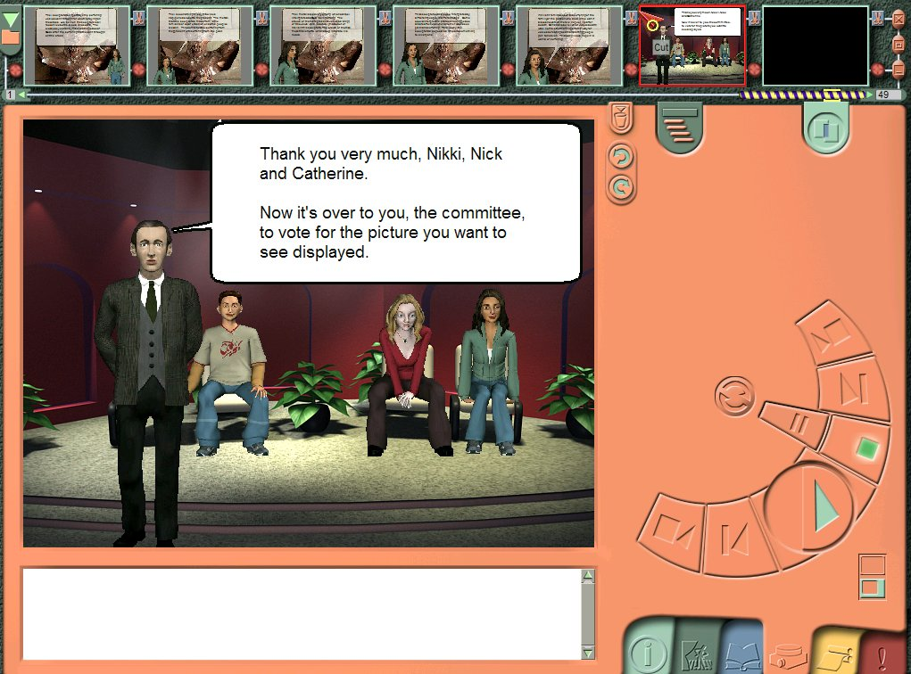
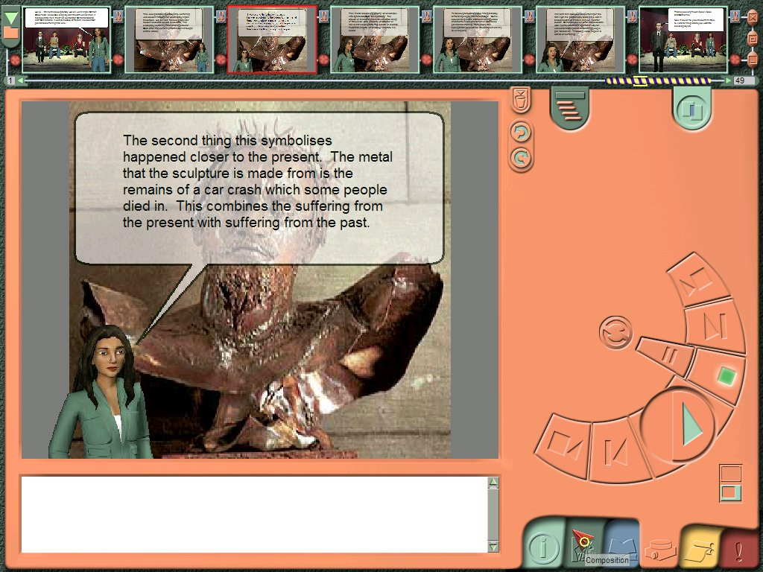
Persuade a sceptical organising committee that their exhibition ‘Life for the 21st century’ ought to include examples of Christian art, explaining why they are relevant.
Pupils were encouraged to use software for creating storyboards and 3-D role plays to develop and present their response to the task. This sort of software encourages collaboration, dialogue and creativity, and helps maintain focus on the demands of the task in an enjoyable way.
Pupils selected a range of images from those studied, and decided whether they would need to focus on different parts of the images for emphasis. They cropped and saved suitable sections and imported them into the storyboarding software as backgrounds so that the characters they created could ‘walk round’ the art work explaining the symbolism, expressing their own views and making links with world issues.
Using a bank of Tablet PCs, pupils worked in pairs. At any point the teacher could select one of the Tablet PCs to project onto the class whiteboard, via a wireless data projector. This enabled pupils to explain how they were proceeding with their task, identifying where they might be struggling technically and in their understanding, and to see how to make further progress. The teacher was able to make explicit comment on their learning as well as challenging any misconceptions.
The use of ICT helped pupils to develop their interpretive and analytic skills, exploring the symbolism of the artworks and evaluating their relevance to today’s world. They were also able to express their own insights and interpretations in a focused way, without the anxiety of having to stand in front of the class. This allowed them to select the most important ideas and communicate them concisely.
Framework theme
Beliefs and concepts
Framework key processes
Analyse religious beliefs, arguments and ideas
Evaluate beliefs, commitments and the impact of religion in the contemporary world
Framework key concepts
Beliefs, teachings and sources
Meaning, purpose and truth
QCA non-statutory unit of work (2007)
How can beliefs and values serve as a guide for decision making? Transition Unit Part B: Communities (Christianity, Judaism and Sikhism)
Online resources
There are thousands of images including illustrations, drawings, paintings and photographs, from collections in the British Library http://www.imagesonline.bl.uk
The Web Gallery of Art [http://www.wga.hu] is an online museum and searchable database of European painting and sculpture from 1100–1850, with more than 20,300 reproductions
The Ackland Museum [http://www.ackland.org/fivefaiths/06_00_00.htm] has a collection of images of religious and sacred art from five religions
Other useful resources
- You can find out about software which supports the creation of storyboards, 3D role-plays, movies, publications and animations from Immersive Education http://www.immersiveeducation.com
What do people from two religions say about death and the afterlife?
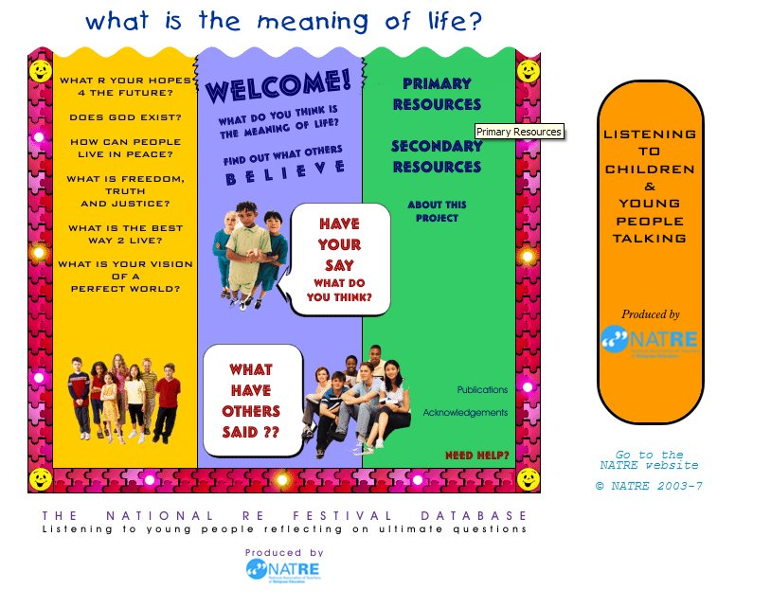
A Year 9 teacher asked her pupils to interrogate ‘Listening to Young People Talking’, an online interactive database of young people’s responses to eleven religious and spiritual questions, to investigate the question: ‘What do people from two religions say about death and the afterlife?’ This class was studying Hinduism and Islam.
By using the database the pupils were able to access the authentic comments of a wide range of young people, selecting religious affiliation, gender, age and topic. They were able to search a vast amount of data and to find the data most useful for the particular task.
The teacher showed pupils the procedure for an ‘advanced’ search so that all pupils could complete a search quickly and efficiently. They then worked in pairs to produce a record of their findings and personal observations. Pupils described the key beliefs expressed by each religion chosen, identified differences between the religions chosen, and between members of the same religion, explained how key beliefs make a difference to people’s lives and reflected on and explained their own views and questions about death and the afterlife.
The teacher prompted the class with further questions designed to encourage them to consider the source and accuracy of data presented, and the legitimacy of any conclusions drawn from it, for example:
How representative of Hindu and Muslim beliefs (or any other religious or non-religious standpoints represented) can the statements in the database be?
What effect might the fact that the database is moderated have on the data available?
In the plenary pupils had the opportunity to compose their own statement about belief in death and the afterlife and submit it to the database.
Framework theme
Beliefs and concepts
Framework key processes
Evaluate how religious beliefs and teachings inform answers to ultimate questions and ethical issues
Express their own beliefs and ideas, using a variety of forms of expression, including creative forms and reasoned arguments
Framework key concepts
Beliefs, teachings and sources
Meaning, purpose and truth
Online resources:
‘Listening to children and young people talking’ [www.natre.org.uk/db] is an online, interactive and fully moderated database of young people’s responses to eleven religious and spiritual questions. The database consists of some 30,000 responses from young people aged 5–19 years who are only identified by age, gender and affiliation to a religious or non-religious world view.
Year 10
Engaging with sacred texts
This year 10 teacher wanted to help his GCSE full course pupils to engage more fully with the sacred texts of the two religions they were studying – Christianity and Islam. Although a fundamental area of understanding for the course, he knew pupils often found it difficult.
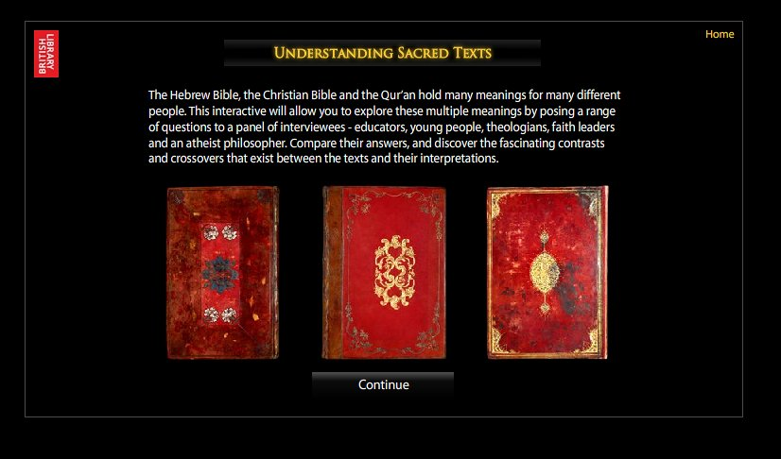
The British Library’s online resource ‘Understanding sacred text’ provided an effective entry point, both in the classroom, and in other places where pupils studied and had internet access.
Working in twos or threes at a computer, pupils worked on one of the five themes presented in the resource: then and now; whose text?; authority and belief; meaning and interpretation; connections. Each theme presented three questions relevant to that theme and five responses (atheist philosopher, academic, young person, educator and faith leader).
Each group recorded their understanding of what each respondent said in key words and short phrases on an Exploratree online thinking guide – ‘From a different angle’. They colour-coded similarities and differences between responses and suggested reasons for these.
Next they reflected on what their own answers to the three questions might be and added their own questions, which they compared with responses from another pair/three that had worked on the same theme and made additions and/or amendments to their thinking guide. Finally they fed back their understanding and remaining questions to the class.
The thinking guides were uploaded to the Exploratree site so that the class could access each other's responses, and thereby access work on all five themes. The thinking guides were also used in subsequent lessons to support ongoing discussion and formal written work.
Framework key concepts
Beliefs, teachings and sources
Meaning, purpose and truth

Framework key processes
Use and develop specialist vocabulary and critical arguments, with awareness of their power, limitations and ambiguity
Evaluate issues, beliefs, commitments and the influence of religion, including philosophical, spiritual and ethical perspectives
GCSE topics:
Revelation and Enlightenment
Authority and importance of sacred texts
Religion and literature
GCSE criteria
AO1 Describe, explain and analyse, using knowledge and understanding
AO2 Use evidence and reasoned argument to express and evaluate personal responses, informed insights, and differing viewpoints
Online resources:
British Library’s Sacred Texts www.bl.uk/learning/cult/sacred/understanding
Exploratree [http://www.exploratree.org.uk] is a free web resource where you can access a library of ready-made interactive thinking guides, print, edit or make your own
A dialogue with charity workers
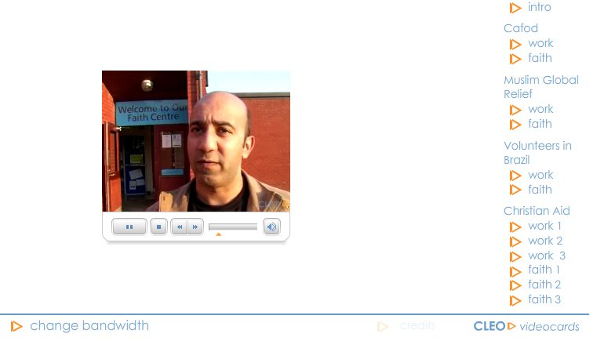
As part of a unit of work on religious attitudes to world poverty, a teacher of Year 10 pupils following a GCSE short course arranged remote dialogue with an aid worker for a national Christian charity working in Nigeria.
To help the pupils make the most of this opportunity, the teacher used ‘Interviews with charity workers’, an online resource on the CLEO website. This presents a series of interviews which provide much information about motivation for charity work (individual and corporate), religious reasons for helping the poor, and examples of types of aid.

Pupils watched one of the interviews and identified:
- examples of emergency and long-term aid provided by the charity
- religious reasons why the religion concerned believes it is right to help the poor
- arguments for and against the statement: ‘Charity begins at home’
- questions of their own about this type of charity work, from the perspective of the individual charity worker, and the charity itself.
The teacher then introduced the class to an online hotseat, a facility on the school learning platform and the mechanism by which they were to communicate with their link charity worker. The invited guest answered moderated questions from the pupils by email over a period of two to three weeks.
The online hotseat was a password-protected ‘question and answer’ application where pupils registered on the system were invited to ask their guest questions. Pupils were allowed to ask as many questions as they liked. The guest was notified by email and decided which questions to answer, how often to respond and in how much detail. The guest used a credit system to award up to 50 points to the questioner, depending on the literacy level, originality and complexity of the question. The hotseat was monitored by the teacher.
At the end of the hotseat, pupils revisited their initial responses to the statement ‘Charity begins at home’. They evaluated this work against their new learning, and wrote a formal response in the light of this. The hotseat generated a great deal of interest in the class, and across the school. Questions were wide ranging, relevant and often complex or profound. Subsequent work by the class demonstrated that they had developed a sound understanding of the impact of belief on choices and behaviour, and were able to ask insightful questions of their own on other issues studied.
Framework key concepts:
Practices and ways of life
Values and commitments
Framework key processes
Investigate and interpret significant issues in the light of their own identities, experiences and commitments
Reflect critically on their opinions in the light of their learning about religions, beliefs and questions

GCSE topic:
Religious attitudes to world poverty
GCSE criteria
AO1 Describe, explain and analyse, using knowledge and understanding
AO2 Use evidence and reasoned argument to express and evaluate personal responses, informed insights, and differing viewpoints
Online resources:
CLEO interviews http://www.cleo.net.uk/resources/displayframe.php?src=629/consultants_resources%2Freligiouseduc%2FbC%2FbC.html (choose ‘interview with charity workers’)
Christian Aid http://www.christianaid.org.uk
CAFOD http://www.cafod.org.uk/
Muslim Aid http://www.muslimaid.org (choose media centre)
Year 11
Questions of science and religion
As part of a unit of work on science and religion, this teacher wanted his GCSE full course pupils to engage with a variety of views about belief in God, and connections between science and religion. A 10-minute video of Professor Richard Dawkins, scientist and fervent atheist, being interviewed by Jeremy Paxman about his book The God Delusion provided a sharply focused resource.
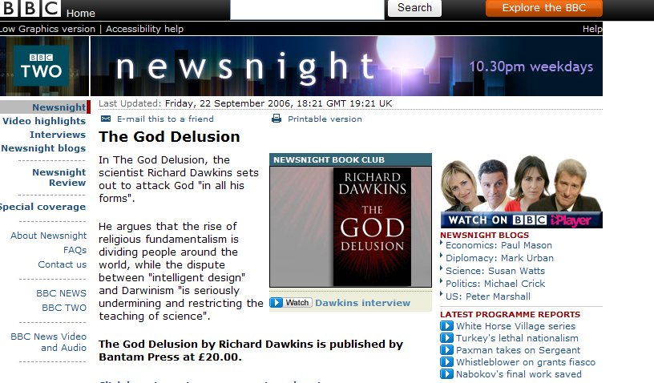
Pupils worked in five groups. Each group watched the interview in order to identify and record what Dawkins had to say about one of the following:
What is truth?
Is there a purpose to existence?
Can there ever be definitive proof that God exists?
What is spirituality? Can this exist without a belief in God?
What is the Bible?
Each group added details to their notes of what people from one of the religions they were studying might say in response to Dawkins, citing the authority they may call on to support their response (for example, sacred text, scientific research, conscience). They then identified a series of questions they would like to ask Dawkins.
Next, two pupils jointly took on the role of Richard Dawkins in a ‘hotseat’ to answer questions put to them by the class whilst other pupils filmed this activity. They edited the footage of the hotseating activity to produce a 4-minute video sequence suitable for one three audiences: atheist, religious believer (such as a Christian or Muslim), or a GCSE RS student. They added subtitles and commentary and presented their final version to the class.
Framework key concepts:
Beliefs, teachings and sources
Meaning, purpose and truth
Framework key processes
Present coherent, detailed arguments about beliefs, ethics, values and issues, with independence and critical awareness of their methods of study
Reflect critically on their opinions in the light of their learning about religions, beliefs and questions
GCSE topic:
Science and Religion
GCSE criteria
AO1 Describe, explain and analyse, using knowledge and understanding
AO2 Use evidence and reasoned argument to express and evaluate personal responses, informed insights, and differing viewpoints
Online resources:
Jeremy Paxman interview with Richard Dawkins http://news.bbc.co.uk/1/hi/programmes/newsnight/5372458.stm
There is a growing collection of video clips of Richard Dawkins, Peter Atkins, Alister McGrath and others on aspects of the science and religion debate on YouTube http://uk.youtube.com
There are also short downloadable video clips about issues related to the science and religion debate from the BBC http://www.bbc.co.uk/learningzone/clips/

